HONG KONG INSTITUTE OF VOCATIONAL EDUCATION

**Laboratory 1: Microsoft Project**

**Module Intended Learning Outcome:**

On completion of the module, students are expected to be able to:

* Exercise appropriate judgment in planning and controlling software development project using Microsoft Project.

**TASK:**

Overview of the user interface

The default view in Project 2013 is the Gantt chart view. It has two main areas, the task table and the timescale. The task table lists the project tasks and their accompanying information. The timescale displays taskbars corresponded to the tasks listed in the task tables. The taskbars show the duration of each task, from their planned start date to their planned finish date, over time. You can move the separator bar between the timescale and the task table to the left or right to display more either area. The timeline provides a graphical view of a project along with a single left access

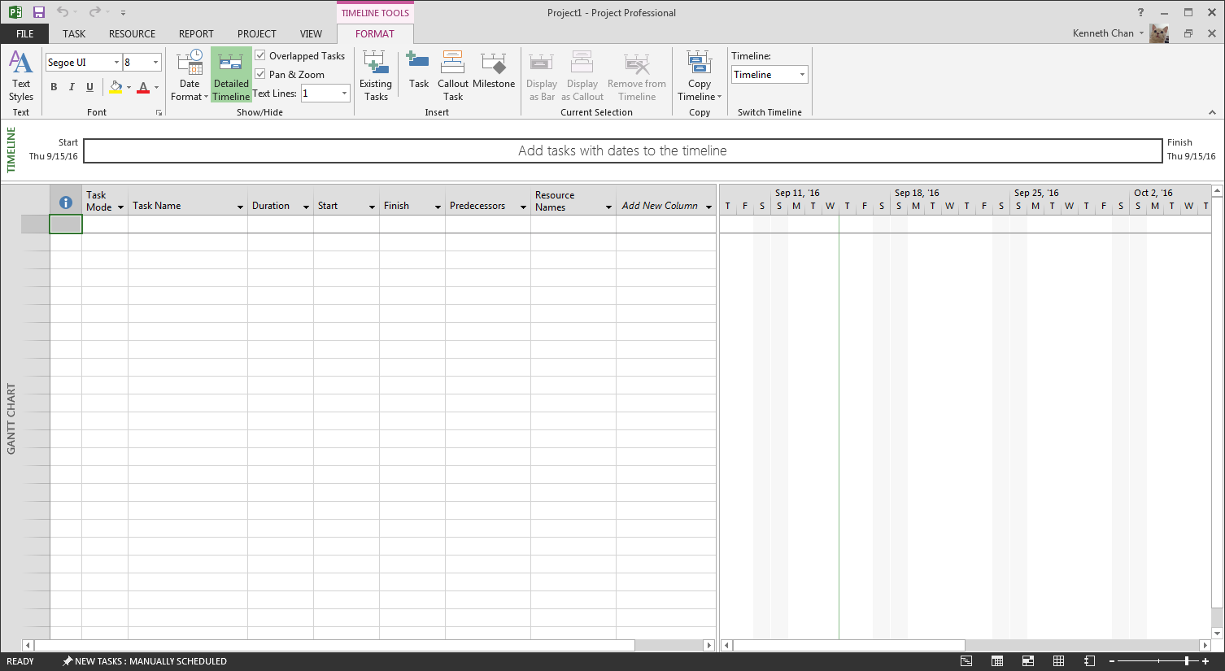

Task Table

Time Scale

Ribbon

Create a new project

1. Click the start button, click all programs, click MS 2013 then click Project 2013. The start screen appears.
2. In the right pane, click Blank Project. A new blank project opens in the program window in the Gantt chart view.

Notes: You can create a new blank project at any time by clicking the file tab on Ribbon click new in the left pane, then click Blank Project in the right pane.

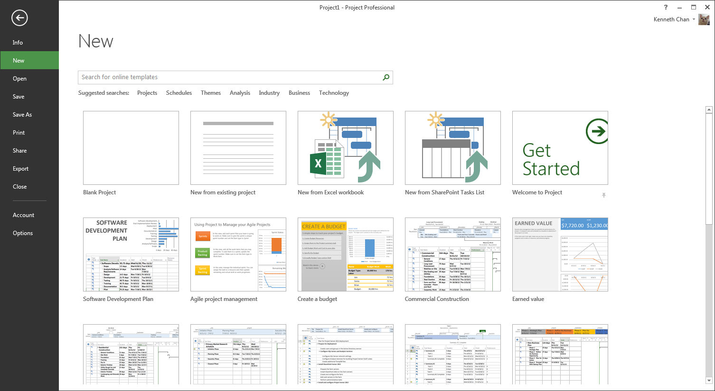

Create a manually scheduled task:

1. In the first row of the task, table enter “**Collect Requirement**” in the task name fields
2. Enter **1w** in the duration field. This sets the duration of the task to one week
3. Enter **the First day of the current year** in the start field. Project 2013 automatically calculates the finish date using the given information and fills the Finish field. Also, a taskbar appears in the timescale showing the task’s time frame.

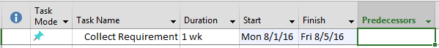

Create an automatically scheduled task

1. In the second row of the task table, enter **“Analysis Requirement”** in the task Name fields
2. Click in the Task Mode field, click **auto-scheduled**. By Default, Project 2013 assigns the task an estimated duration of one day and automatically fills in the duration, start and finish fields. Also, a taskbar appears in the timescale showing that task’s time frame.
3. To change the duration of the task to two days enter **2d** in the duration field. Project 2013 recalculates the finish date and updates the Finished Field.

Link tasks

1. In the third row of the task, table creates a new manually scheduled tasked named **“Compose analysis report”** and set the duration to two weeks. Leave the start and finish fields empty.
2. In the task name column, select all three tasks.
3. On the task table of the ribbon, in the schedule group, click the link the selected task button. Project 2013 fills in the start and finish fields of the **“Compose analysis report”** task and links the three tasks by adding link lines between the taskbars in the timescale.

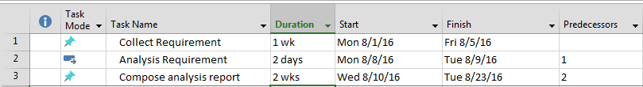

1. To see the advantage of automatically scheduled tasks change the duration of “**Collect Requirement**” to 2 weeks. In the time scale notes that that start date of the automatically scheduled task, preparation and planning was automatically adjusted. The start date of the manually scheduled task **“Compose analysis report”** was not automatically adjusted and will need to be adjusted manually.
2. Change the duration of the “**Collect Requirement**” back to 1 week.

Create a summary task

1. In the task name column drag to select all three tasks
2. On the task table ribbon, in the Insert group, click the insert summary button. Project 2013 inserts the new summary task above the three tasks fills in the task name field with the text new summary task and turns the three task below it into subtask
3. Enter **“Requirement Analysis”** in the task name field of the summary task

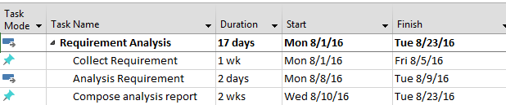

Updating task progress

1. To update a task’s percentage of completion, in the task name column, double-click the “**Collect Requirement**”, the task information dialogue box opens.
2. On the general tab, in the percent complete box, enter 50%.
3. Click the ok button, in the timescale, a progress bar is added within the “**Collect Requirement**” to show progress on the task.

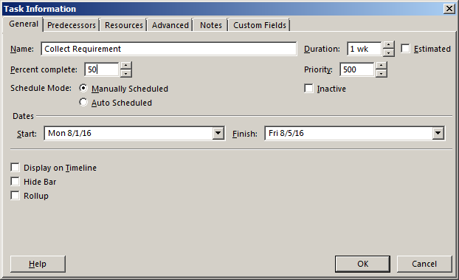

To add a work resource

1. On the view table of the ribbon, in the resource views group, click the resource sheet button to switch to the resource sheet view.
2. In the first row enter “**Student A**” in the resource name field, the type field is set to **work**.
3. Enter **SA** in the initials field.
4. Enter **YR1 student** in the group field
5. Enter **35** in the Std. Rate field. This sets the hourly rate for that work to 35.

Change resource work hours

1. In the resource name column, double-click the “Student A” resource. The resource information dialogue box opens.
2. On the general tab, click the changing working time button. The change working time dialogue box opens.
3. Click the work week tab in the lower section of the dialogue box.
4. In the name column, double-click the default work week [Button]. The details for default dialogue box opens.
5. In the select day box, select Monday through Friday and select the set day to these specific working times option
6. Change the from time in the first row at 9 am and the to time in the second row to 6 pm
7. Click the ok button in each dialogue box to apply the changes.

Assigning a resource to a task

1. On the crew tab of the ribbon in the task views group, click the Gantt chat bouton to switch to the Gantt chart view
2. In the task table, click on the resource names field of the “**Collect Requirement**”, and select the checkbox next to **“Student A”** to assign him to the task

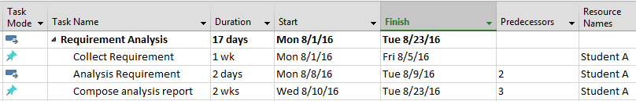

To change a project’s work hours

1. On the project tab of the ribbon, in the Properties group, click the change working time button. The change working time dialogue box opens.
2. Click the work weeks tab in the lower section of the dialogue box
3. In the name column, double-click the default work week. The details for default dialogue box opens.
4. In the select day box, select Monday through Friday and Select the set day to these specific working times options
5. Change the “from time” on the first row to 9 am and the “to time” to the second row to 6 pm,
6. Click ok button
7. In the change working time dialogue box, click the options button, the project options dialogue box opens to display the schedule options.
8. In the right pane, change the default start time to 9 am and the default end time to 6 pm
9. Click OK

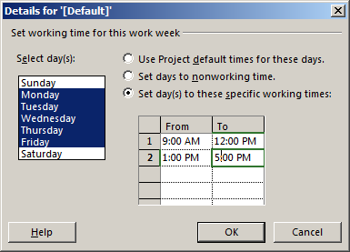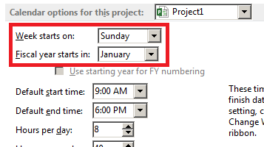

Setting a schedule to constrain

1. Make sure that the grant chart view is displayed
2. On the task tab of the ribbon, in the Properties group, click the display task details button. The task details form vie displays below the Gantt chart view.
3. In the Gantt chart view, in the task name column of the task table, click to select the **Compose analysis report”**.
4. In the task details form view, deselect the manually scheduled check box. This changes the task from the manual schedule to auto-scheduled which is required for testing scheduling constraints.
5. In the constraint section, select start no earlier than from the constraint list.
6. Set the date to one day after its original start date
7. Click the ok button. The start and finish dates of the “**Compose analysis report”** task are updated in the task table.

Assigning multiple resources to a task

1. First, add another work resource. The name is “Student B”, type field is “work”, initials are “SB” and group is “Year 2 Student”, set the hourly rate to 50.
2. Switch to the grant chart view and select the “**Compose analysis report”** task.
3. On the resource tab of the ribbon, in the assignments group, click the assign resource button. The assign resource dialogue box opens.
4. In the resource name column, lick to select “Student B” resource and then the click the assign button
5. Click to select the “Student B” resources and then click the assign button
6. Click the close button
7. Click the exclamation icon that appears to the left of the website draft cell and select the reduce duration but keep the same amount of work. Option as the reason for assigning two resources to the task.

Create a work exception

1. In the Gantt chart view, make a note of the week during which the “**Compose analysis report”** task is scheduled.
2. On the view tab of the ribbon, in the resource views group, click the resource sheet button to switch to the resource sheet view.
3. In the resource name column, double-click the “Student A” resource. The resource information dialogue box opens.
4. On the general tab, click the change working time button. The change working time dialogue box opens
5. On the Exceptions tab, enter sick in the first row of the name column
6. Set the start date to the Tuesday of the week that the “**Compose analysis report”** 1 task is scheduled.
7. Click the OK button in each dialogue box.
8. On the view tab of the ribbon, in the task views group, click the Gantt chart button to switch to the Gantt chart view. Notice that the task has been extended to the next working day so that it can be completed since one of the resources assigned to the task is going to miss a day.

**Exercise:**

Referring to the lab case, draw the Gantt chart and estimate the finishing date for the project.